Languages: English, Chinese

[GPA](javascript:openGlossary(10001,'PP');): 2.5

[Housing Options](javascript:openGlossary(10002,'PP');) International Student and Faculty Building at Guizhou University

Max Credits Offered: 6-9

Area of Study: Decoding China, Chinese Language, Multicultural Writing

Program Type: WCU Faculty

Credit Type: Direct WCU Credits & Transfer Credits

Faculty Director: Jie Cai, William Lalicker, Lin Tan

[Available to Non-WCU Students](javascript:openGlossary(10008,'PP');)

==========================================================================================================================================================================

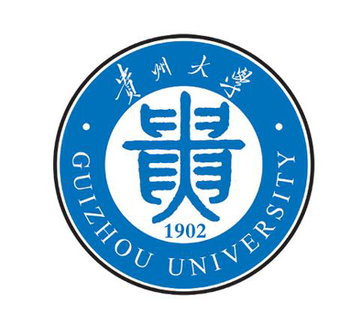

**2013 SUMMER SESSION I STUDY ABROAD**

**AT GUIZHOU UNIVERSITY CHINA**

**(May 29, 2013-June 29, 2013)**

**Program Description:**

West Chester University (WCU) and Guizhou University (GU) are providing a 4-weeks study abroad program in 2013 summer session I at Guizhou University, China. In addition to the academic studies, daily cultural activities, weekend excursions of beautiful Guizhou Province, and Beijing & Shanghai tours, are included in the program.

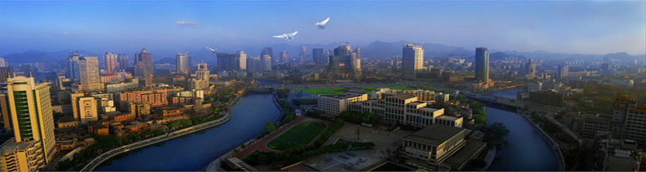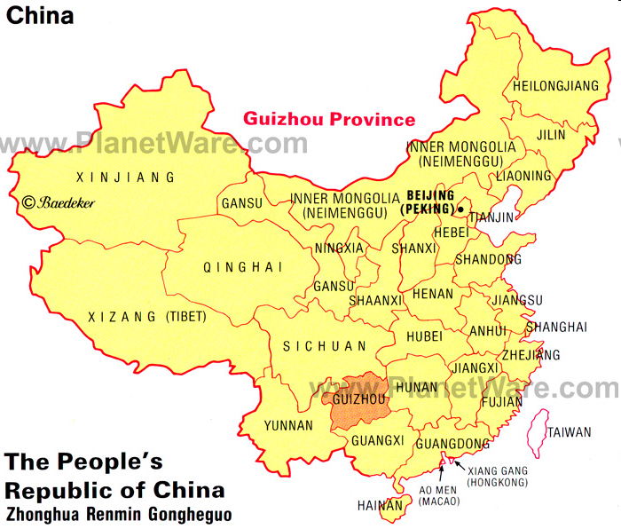

Guizhou University (GU), the hosting university in China, is located in China’s southwestern region. Students will see a much diversified China, including diverse ethnic, social, and economic aspects of this dynamic country. Join the program to:

* immerse in a language and culture performed by over 1 billion people;
* experience the cultural diversity of Han and minority tribal peoples;
* discuss key contents in Chinese cultural, social and economic fields;
* participate in hands-on recreational activities; experience Chinese life and beliefs;
* witness the contradictions and constancies in the interchange between tradition and modernity in today’s China;
* consider world globalization’s fostering of multiple cultures and intercultural diversities.

**Program Offers Three Courses:**

* Decoding China (ECH199) (transfer credits from GU, in English)
* Chinese Modern Language (LAN 411) (direct WCU credits, in English & Chinese)
* Multicultural Writing (WRH 210) (direct WCU credits, in English)

Students take two or three courses where one of them needs to be Decoding China (ECH199). Check details in program flyer and course syllabus.

**Program Fee:**

Program fee is $1280 for a two courses registration (ECH199 & LAN411, or ECH199 & WRH210). This budget covers the cost for:

* course registration fee;
* Passport and visa application fee as well as travel insurance fee;
* 2-3 days Beijing tour (tour guide, transportation, tour site tickets, lodging and some meals);
* 1 night accommodation at Shanghai;
* Meals and accommodation at Guizhou University;
* Weekend excursions at Guizhou province.

Check details in program flyer.

**Program Contact:**

Please contact Dr. Jie Cai, Department of Languages and Cultures, at [jcai@wcupa.edu](mailto:jcai@wcupa.edu), with any questions or concerns for this program.